Orbital Eccentricity
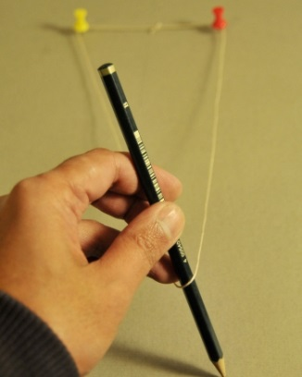
Planets, asteroids, and comets don’t travel around the sun in perfect circles. Their orbits are stretched out into a shape called an ellipse. The sun, rather sitting right in the center of the shape formed by the satellite’s path, sits a bit off center at a point called the focus. The orbit’s eccentricity is a way of measuring how much the orbit deviates from a perfect circle, and is measured using a number between zero and one. An eccentricity of zero means the orbit is a circle. The closer the eccentricity is to one, the more stretched out the orbit is. In this project, you will explore different orbit shapes and make models of the planets’ orbits.

Materials
- Pencil
- Ruler
- 2 pushpins
- 12-inch (31-cm), square piece of poster board (or plain paper)
- 12-inch (31-cm), square piece of thick cardboard
- 10-inch (26-cm) length of string

Procedure
- Draw a straight line through the center of the paper.
- Mark two dots on the line 4 inches apart at the center of the paper.
- Place the paper on top of the cardboard and stick the pushpins into the dots.
- Tie the loose ends of the string together to make a loop.
- Drape the string loop around the pushpins. Place the pencil inside the loop as well and use it stretch the loop into a triangle.
- Keeping the string taut, guide the pencil around the pushpins while tracing out a path on the paper below. Continue around the pins until you’ve drawn a closed loop.
- Repeat the above steps on the same paper with the pins at different distances from each other: 0 inches (just use one pin), 3 inches, and 5 inches. How does the shape of the loop change? How does the distance across the widest and narrowest parts change as the pins get closer together?

Results
You have four ellipses on the poster board/paper. Each pushpin marks a point in the ellipse called a focus (plural: foci). The widest diameter across the ellipse is called the major axis; the narrowest diameter is known as the minor axis. The foci sit along the major axis, equidistant from the center of the ellipse. As the foci get closer together, the ellipse looks more like a circle. An ellipse with only one focus is a circle (the major and minor axes are the same length).
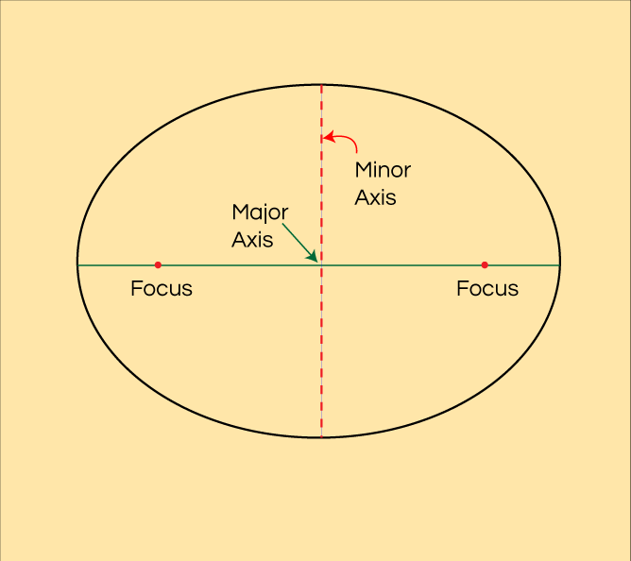

Why?
In 1609, Johannes Kepler figured out that the planets travel along elliptical paths with the sun sitting at one focus of the ellipse. He called this his First Law of Planetary Motion. As a planet moves along its orbit, the distance between it and the sun changes. The point on the ellipse where the planet is closest to the sun is called the perihelion; the point where it is farthest is the aphelion. The Earth passes its perihelion in early January and goes through aphelion in early July. On your ellipses, mark where the perihelion(P) and aphelion(A) are.
The eccentricity of an orbit is a single number, between 0 and 1, which describes how stretched out the orbit is. Zero means the orbit is perfectly circular. An eccentricity close to 1 means the orbit is extremely elongated; only comets coming from the outer reaches of the solar system get close to this value.
You can calculate the eccentricity of your ellipses using the following equation:
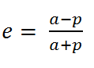
- where e is the eccentricity,
- a is the aphelion distance, and
- p is the perihelion distance.
For each ellipse, pick a focus where the sun should sit (either one will do), then measure the aphelion and perihelion distances. Calculate the eccentricity, and record your results in Table 1.

Orbital Eccentricity Name______________________

Distance between foci | Aphelion | Perihelion | Eccentricity
0 inches
3 inches
4 inches
5 inches
Table 1. Calculating the eccentricity of your ellipses
How does the eccentricity change as the foci get farther apart?
Table 2 lists the aphelion and perihelion distance of all the major planets (plus one famous comet). The distances are in astronomical units (AU), where 1 AU is the average distance between the Earth and Sun (93 million miles).
Name | Aphelion (AU) | Perihelion (AU) | Eccentricity
Mercury | 0.47 | 0.31
Venus | 0.73 | 0.72
Earth | 1.02 | 0.98
Mars | 1.67 | 1.38
Jupiter | 5.46 | 4.95
Saturn | 10.12 | 9.05
Uranus | 20.08 | 18.38
Neptune | 30.44 | 29.77
Comet Halley | 35.1 | 0.59
Table 2. Orbits in the solar system

