Table 1: Bright Stars

Star | M(V) | log(L/L_{sun}) | Temp | Type | Star | M(V) | log(L/L_{sun}) | Temp | Type
Sun | 4.8 | 0.00 | 5840 | G2 | Sirius A | 1.4 | 1.34 | 9620 | A1
Canopus | -3.1 | 3.15 | 7400 | F0 | Arcturus | -0.4 | 2.04 | 4590 | K2
Alpha  Centauri A | 4.3 | 0.18 | 5840 | G2 | Vega | 0.5 | 1.72 | 9900 | A0
Capella | -0.6 | 2.15 | 5150 | G8 | Rigel | -7.2 | 4.76 | 12140 | B8
Procyon A | 2.6 | 0.88 | 6580 | F5 | Betelgeuse | -5.7 | 4.16 | 3200 | M2
Achemar | -2.4 | 2.84 | 20500 | B3 | Hadar | -5.3 | 4.00 | 25500 | B1
Altair | 2.2 | 1.00 | 8060 | A7 | Aldebaran | -0.8 | 2.20 | 4130 | K5
Spica | -3.4 | 3.24 | 25500 | B1 | Antares | -5.2 | 3.96 | 3340 | M1
Fomalhaut | 2.0 | 1.11 | 9060 | A3 | Pollux | 1.0 | 1.52 | 4900 | K0
Deneb | -7.2 | 4.76 | 9340 | A2 | Beta Crucis | -4.7 | 3.76 | 28000 | B0
Regulus | -0.8 | 2.20 | 13260 | B7 | Acrux | -4.0 | 3.48 | 28000 | B0
Adhara | -5.2 | 3.96 | 23000 | B2 | Shaula | -3.4 | 3.24 | 25500 | B1
Bellatrix | -4.3 | 3.60 | 23000 | B2 | Castor | 1.2 | 1.42 | 9620 | A1
Gacrux | -0.5 | 2.10 | 3750 | M3 | Beta Centauri | -5.1 | 3.94 | 25500 | B1
Alpha Centauri B | 5.8 | -0.42 | 4730 | K1 | Al Na'ir | -1.1 | 2.34 | 15550 | B5
Miaplacidus | -0.6 | 2.14 | 9300 | A0 | Elnath | -1.6 | 2.54 | 12400 | B7
Alnilam | -6.2 | 4.38 | 26950 | B0 | Mirfak | -4.6 | 3.74 | 7700 | F5
Alnitak | -5.9 | 4.26 | 33600 | O9 | Dubhe | 0.2 | 1.82 | 4900 | K0
Alioth | 0.4 | 1.74 | 9900 | A0 | Peacock | -2.3 | 2.82 | 20500 | B3
Kaus Australis | -0.3 | 2.02 | 11000 | B9 | Theta Scorpii | -5.6 | 4.14 | 7400 | F0
Atria | -0.1 | 1.94 | 4590 | K2 | Alkaid | -1.7 | 2.58 | 20500 | B3
Alpha Crucis B | -3.3 | 3.22 | 20500 | B3 | Avior | -2.1 | 2.74 | 4900 | K0
Delta Canis Majoris | -8.0 | 5.10 | 6100 | F8 | Alhena | 0.0 | 1.90 | 9900 | A0
Menkalinan | 0.6 | 1.66 | 9340 | A2 | Polaris | -4.6 | 3.74 | 6100 | F8
Mirzam | -4.8 | 3.82 | 25500 | B1 | Delta Vulpeculae | 0.6 | 1.66 | 9900 | A0

Table 2: Nearby Stars

Star | M(V) | log(L/L_{sun}) | Temp | Type | Star | M(V) | log(L/L_{sun}) | Temp | Type
Sun | 4.8 | 0.00 | 5840 | G2 | *Proxima  Centauri | 15.5 | -4.29 | 2670 | M5.5
*Alpha  Centauri A | 4.3 | 0.18 | 5840 | G2 | *Alpha  Centauri B | 5.8 | -0.42 | 4900 | K1
Barnard's Star | 13.2 | -3.39 | 2800 | M4 | Wolf 359 (CN Leo) | 16.7 | -4.76 | 2670 | M6
HD 93735 | 10.5 | -2.30 | 3200 | M2 | *L726-8 ( A) | 15.5 | -4.28 | 2670 | M6
*UV Ceti (B) | 16.0 | -4.48 | 2670 | M6 | *Sirius A | 1.4 | 1.34 | 9620 | A1
*Sirius B | 11.2 | -2.58 | 14800 | DA | Ross 154 | 13.1 | -3.36 | 2800 | M4
Ross 248 | 14.8 | -4.01 | 2670 | M5 | Epsilon Eridani | 6.1 | -0.56 | 4590 | K2
Ross 128 | 13.5 | -3.49 | 2800 | M4 | L 789-6 | 14.5 | -3.90 | 2670 | M6
*GX Andromedae | 10.4 | -2.26 | 3340 | M1 | *GQ Andromedae | 13.4 | -3.45 | 2670 | M4
Epsilon Indi | 7.0 | -0.90 | 4130 | K3 | *61 Cygni A | 7.6 | -1.12 | 4130 | K3
*61 Cygni B | 8.4 | -1.45 | 3870 | K5 | *Struve 2398 A | 11.2 | -2.56 | 3070 | M3
*Struve 2398 B | 11.9 | -2.88 | 2940 | M4 | Tau Ceti | 5.7 | -0.39 | 5150 | G8
*Procyon A | 2.6 | 0.88 | 6600 | F5 | *Procyon B | 13.0 | -3.30 | 9700 | DF
Lacaille 9352 | 9.6 | -1.93 | 3340 | M1 | G51-I5 | 17.0 | -4.91 | 2500 | M7
YZ Ceti | 14.1 | -3.75 | 2670 | M5 | BD +051668 | 11.9 | -2.88 | 2800 | M4
Lacaille 8760 | 8.7 | -1.60 | 3340 | K5.5 | Kapteyn's Star | 10.9 | -2.45 | 3480 | M0
*Kruger 60 A | 11.9 | -2.85 | 2940 | M3.5 | *Kruger 60 B | 13.3 | -3.42 | 2670 | M5
BD -124523 | 12.1 | -2.93 | 2940 | M3.5 | Ross 614 A | 13.1 | -3.35 | 2800 | M4
Wolf 424 A | 15.0 | -4.09 | 2670 | M5 | van Maanen's Star | 14.2 | -3.78 | 13000 | DB
TZ Arietis | 14.0 | -3.70 | 2800 | M4 | HD 225213 | 10.3 | -2.23 | 3200 | M22
Altair | 2.2 | 1.00 | 8060 | A7 | AD Leonis | 11.0 | -2.50 | 2940 | M3.5
*40 Eridani A | 6.0 | -0.50 | 4900 | K1 | *40 Eridani B | 11.1 | -2.54 | 10000 | DA
*40 Eridani C | 12.8 | -3.20 | 2940 | M3.5 | *70 Ophiuchi A | 5.8 | -0.40 | 4950 | K0
*70 Ophiuchi B | 7.5 | -1.12 | 3870 | K5 | EV Lacertae | 11.7 | -2.78 | 2800 | M4

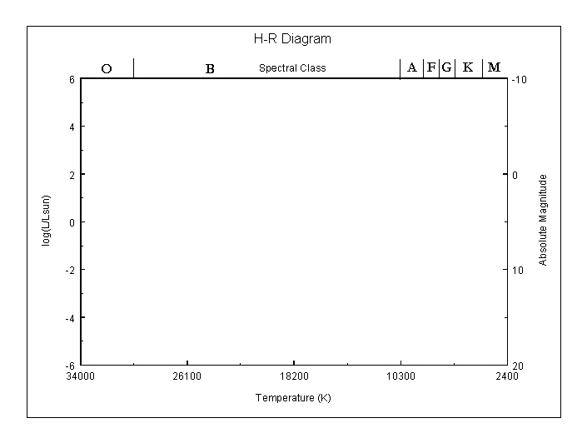

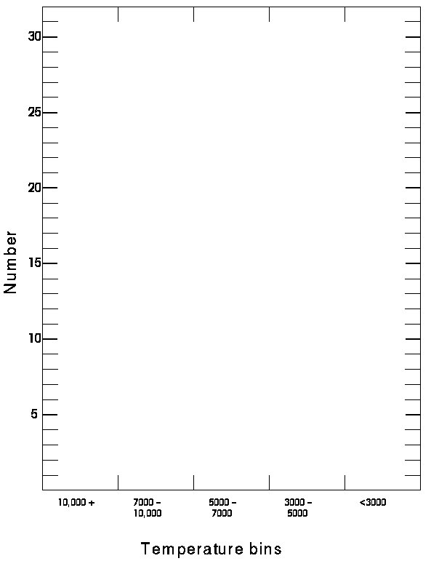

The H-R Diagram
Introduction
In the early part of this century, two astronomers, one Danish and one American, invented a diagram showing the basic characteristics of stars. The color-magnitude diagram, often called the Hertzsprung-Russell (HR) diagram in their honor, has proved to be the Rosetta Stone of stellar astronomy. The purpose of this activity is to give you some familiarity with the diagram. In addition, you will be asked to investigate the types of biases in measurement used to construct this diagram.

This exercise asks you to make comparisons between two different samples of stars. The bright star table was selected on the basis of apparent brightness NOT the luminosity of the stars. The near star table is all stars within 5 parsecs (about 15-16 lightyears) from the Sun.
Procedure
- The first thing an astronomer does when faced with a pile of data is gaze at it, contemplates it, and wait for inspiration. Look over the two lists of stars and compare them to the star we know best, the Sun:
  - Characterize the average properties of stars in the "Near Star List" as compared to the Sun. (mention Luminosity, color, and temperature.) "Nearby stars tend to be...."
  - Characterize the average properties of stars in the "Bright Star List" as compared to the Sun. (mention Luminosity, color, and temperature.) "Apparently bright stars tend to be...."
Plot log(L/L_{Sun}) versus Temperature for both the lists of nearest stars and brightest stars on the accompanying graph. Use contrasting colors or symbols so that the two samples of stars are clearly distinguished. The plot you have made will be an HR diagram. Label the region of the diagram where the main-sequence stars, Red Giant stars and White Dwarf stars are found.

Note: L/L_{Sun} describes how much more luminous a star is than our Sun
So, If L/L_{Sun}=2, then the star is 2 times as luminous as the Sun.
Likewise,
R/R_{Sun} describes how much larger the radius of a star is compared to our Sun
T/T_{Sun} describes the temperature of a star compared to our Sun
2. In a brief sentence or two, comment on the differences in location on your plot of these two groups of stars.

3. Capella has approximately the same temperature as the Sun, yet it is 140 times as bright as the Sun. We know that the luminosity of a star is
L/L_{Sun}=(R/R_{Sun})²*(T/T_{Sun})⁴.
Knowing this, propose an explanation for the higher luminosity of Capella.

4. For each list of stars, the nearest stars and the brightest stars, count the number of stars that fall into each of these temperature ranges: 3000 or less; 3001 to 5000; 5001 to 7000, 7001 to 10,000; greater than 10,000. Make a bar graph for each set using the second diagram. Again, use contrasting colors for the two samples so they can be easily distinguished from one another.
Note: some star systems have more than one star in them; count each star in the system individually. For example the 40 Erid system is made of three stars, each of different temperature.
5. In a sentence or two, comment briefly on the differences between two samples of stars on the histogram you have drawn.

6. We are not able to catalog all the stars in our Galaxy. However, if we assume that the Sun is situated in a typical piece of Galaxy, we should be able to assemble a sample of stars which accurately reflects the population of the whole Galaxy (e.g. when pollsters want to find out the President's approval rating, they don't ask ALL Americans, but rather they assemble a sample of ~1000 typical Americans and assume that this sample accurately reflects the whole population.)
Which list (the bright star list or the near star list) would best be a representative of the total population of the Galaxy? Explain why!

7. Besides giving us insight into the soul and disposition of stars, the HR diagram can be used to more pragmatic ends. You can use the HR Diagram you constructed to find the distances to stars via the method of spectroscopic parallax. Listed below are the apparent magnitudes and spectral types of six main sequence stars.

Spectroscopic parallax distance determination
Star | Apparent  Magnitude (m) | Spectral  Class | Absolute  Magnitude (M) | m - M | Distance
Sirius | -1.4 | A1
Spica | 1.0 | B1
Barnard's Star | 9.5 | M4 V
61 Cygni A | 5.2 | K5 V
CN Leonis | 3.5 | M6 V
Tau Cet | 3.5 | G8

Use the spectral types and the HR diagram to estimate their absolute magnitudes. The difference between the apparent and absolute magnitudes is called the distance modulus. Calculate the distance modulus (m-M) for these six stars. The distance to a star (in parsecs) is given by:

D=10^{(m-M+5)/5}

Calculate the distance to each of these stars.

What assumptions are you making as you derive your distance estimate?

How accurate do you think your distance estimate is?

- Using this formula,
(R/R_{Sun})²=(L/L_{Sun})(T/T_{Sun})⁻⁴
and the lists, find the radius of the hot main-sequence star Vega, the very hot main-sequence star Hadar and the cool main-sequence star Ross 614-A as ratios of the radius of the Sun.

R_{Vega}/R_{Sun} =

R_{Hadar}/R_{Sun} =

R_{Ross 614-A}/R_{Sun} =

Note: In order to find L/L_{Sun} from the lists, you need to know about logarithms. Here is a quick reminder:
log(L/L_{Sun})=x
means that
L/L_{Sun}=10^{x}
Let's use a real number to work this out. Suppose that x=2, so that
log(L/L_{Sun})=2
Then
L/L_{Sun}=10²
and therefore
L/L_{Sun}=100
So the star is 100 times as luminous as the Sun.
- From the above calculation, do you see any trend between the size of a main-sequence star and its temperature? If so, what is it?

